*DOUBTS*

1. In your feedback comments, related with the ‘number of bits’ of the data type ‘void’, you marked the following red square:

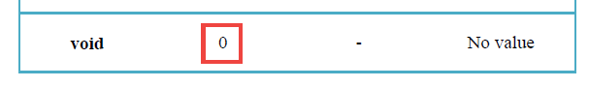

Could you explain me what is the ‘number of bits’ of the data type ‘void’?

1. In regard to lab session 4: could you tell me what do you want to mean when you use the Word ‘macros’?
2. In regard to lab session 4 – PART 3 – paragraphs 3 and 4:

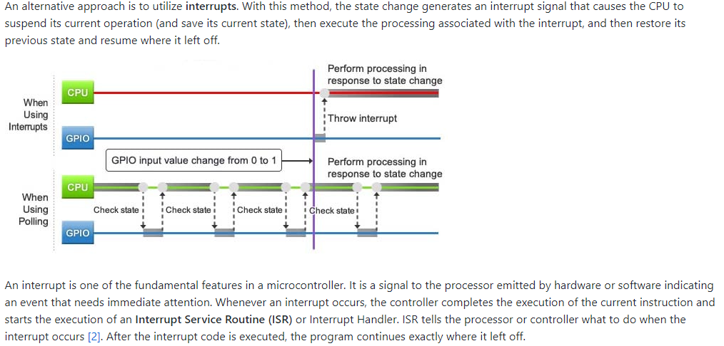

I don’t understand if finally the interrupt stops whatever Micro is doing at this moment and execute the interrupt (**first paragraph**), or if the Micro finish whatever it is doing at this moment and after executes the interrupt (**second paragraph**)